DASHBOARD DESIGN
India's Agricultural Crop Production Analysis
Date | 07 October 2026
Team ID | To be filled
Project Name | India's Agricultural Crop Production Analysis
Technology / Tool | Tableau Public
Maximum Marks | 5 Marks
Dashboard Overview
The dashboard presents an interactive analysis of India's agricultural crop production for the period 1997–2021. It combines key performance indicators, crop-wise production, season-wise production share, state-wise cultivated area, year-wise production, agricultural yield trends, a geographic production map, and leading-state comparisons. The dashboard is designed to help users quickly understand production patterns, geographical differences, crop dominance, seasonal distribution, and changes over time.
Activity 1: Interactive and Visually Appealing Dashboard
1. Clear and Intuitive Layout
The dashboard places the project title at the top, followed by two KPI cards and a structured grid of analytical visuals. The main dashboard contains Total Agricultural Yield and Total Agricultural Production KPIs, followed by crop, season, area, trend, map, and state-comparison visuals.
2. Use of Appropriate Visualizations
The dashboard uses visualization types appropriate to each requirement: KPI tiles for totals, a horizontal bar chart for crop-wise production, a pie chart for season-wise production share, a cultivated-area comparison, a line chart for yield trend, a bar chart for yearly production, a filled map for state-wise production distribution, and a bar chart for leading states.
3. Colour and Theming
A clean Tableau-style theme with a light background and consistent typography is used. Production is represented using a sequential scale where applicable, while the Season legend distinguishes Autumn, Kharif, Rabi, Summer, Whole Year, and Winter. The restrained colour usage keeps the dashboard readable.
4. Interactive Filters and Slicers
The project supports interactive analysis through State, Crop, Season, Production, and Year/Area-related controls where applicable. These controls allow users to narrow the dataset and examine specific portions of agricultural production.
5. Drill-Down Capabilities
The dashboard supports analytical drill-down through multiple levels of detail. Users can move from overall KPIs to state-level production, crop-level production, season-level share, yearly production, cultivated area, and yield trends. The accompanying Tableau Story provides a progressive analytical view.
6. Responsive Design
The dashboard size is set to Automatic so that the layout adapts to the available Tableau viewing area. The visuals are organized in a structured grid to maintain readability when viewed in Tableau Public.
7. Custom Visuals and Icons
The dashboard focuses on analytical Tableau visuals rather than decorative icons. The project-specific arrangement of KPI cards, charts, map, legends, and titles creates a unified analytical dashboard.
8. Use of Infographics
The KPI values and charts act as analytical infographics. The map provides geographic context, while the crop, season, state, and time-series visuals summarize complex agricultural data in an easy-to-understand form.
Dashboard Components and Actual Project Results
Dashboard Component | Project-Specific Result / Purpose
KPI – Total Agricultural Production | 330,997,839,211
KPI – Total Agricultural Yield | 2,931,611,903
Crop-wise Total Production | Coconut is the dominant crop in the displayed crop-wise analysis, followed by Sugarcane, Rice and other crops.
Season-wise Production Share | Whole Year is the dominant season category; Rabi contributes a much smaller share.
State-wise Cultivated Area | Compares cultivated area across states and crops.
Agricultural Yield Trend | The 1997–2021 line chart shows substantial year-to-year variation, including a pronounced peak around 2017.
Year-wise Agricultural Production | Production varies across the 1997–2021 period, with higher values in several later years.
State-wise Production Map | The filled India map shows geographic differences in agricultural production.
Leading States by Production | Kerala is the leading state in the displayed ranking, followed by Tamil Nadu and Karnataka.
Major Outcomes / Observations
• The dashboard reports total agricultural production of 330,997,839,211 in the current Tableau workbook view.
• The total agricultural yield displayed on the dashboard is 2,931,611,903.
• Coconut is the most prominent crop by total production in the displayed crop-wise analysis.
• Whole Year is the dominant category in the season-wise agricultural production share.
• Kerala ranks first in the displayed leading-state production comparison, followed by Tamil Nadu and Karnataka.
• The yield trend from 1997–2021 shows strong variation, with a prominent spike around 2017.
• The year-wise production chart demonstrates changing agricultural production levels across the 1997–2021 period.
• The geographic map makes differences in agricultural production across Indian states easier to identify.
• The dashboard brings multiple analytical views together in a single interface, making it useful for agricultural production comparison and trend analysis.
Activity 2: Publish Dashboard on Tableau Public
The completed dashboard is intended to be published on Tableau Public so that the interactive visualization can be accessed through a web browser. After publishing, the actual Tableau Public URL should be pasted below.
Tableau Public Dashboard Link: To be added after publishing
Dashboard Screenshot
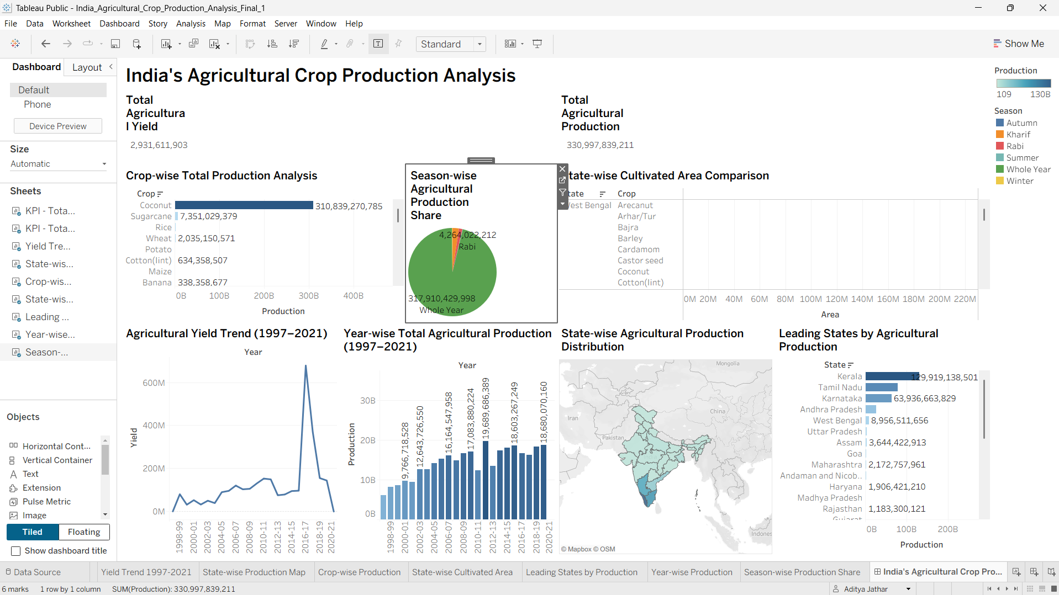
Figure: Final Tableau dashboard – India's Agricultural Crop Production Analysis
Dashboard Conclusion
The completed Tableau dashboard provides a consolidated view of India's agricultural crop production from 1997 to 2021. By combining KPIs, crop-wise and season-wise analysis, state comparisons, geographic distribution, cultivated area, yearly production, and yield trends, the dashboard supports quick identification of major production patterns and differences. It also forms the main visual foundation for the project's Tableau Story.

